Grade 2
Dot to Dot Game

Description: | Students will:  Make a grid on a playfield.  Decide the scale of grid.  Use the grid to make a five by five array of dots at vertices.  Make efficient use a stamp tool to copy sets of dots.  Draw a line segment for player one, copy it, and change the heading.  Copy the two game pieces and change the color for player two.  Use maker buttons to provide a supply of game pieces.  Invent a way to show which player captures a square.  Play the game enough times to develop a strategy.
Project View | 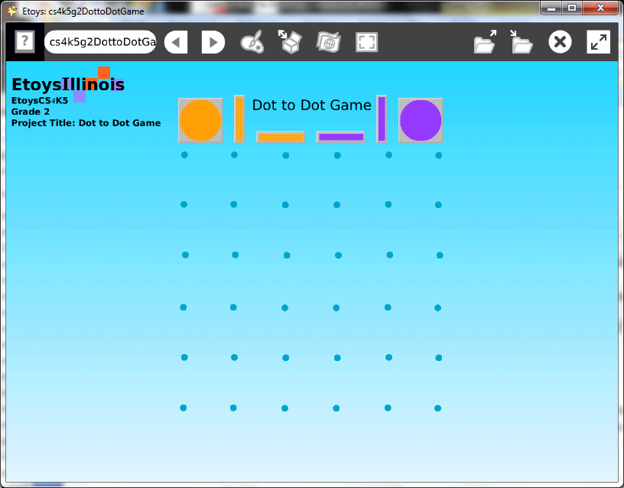
Subject: | Math
Etoys Quick Guides | Click the question mark in Etoys to open the set of interactive tutorials for basic tools and techniques.
Vocabulary: | Vertex, vertices, line segment, grid, scale, array, vertical, column, horizontal, row, plan, headings zero, 0, ninety, 90, degrees, efficient
Lesson 1:  Menus: Playfield Graph Paper  Paints: Brushes  Paints: Stamp Tool  Navigator Bar: Keep Find Projects | Making the game grid: open a playfield from Supplies and use the white menu in the halo of handles to make a grid on the playfield. Students should experiment with several sizes of the grid.  Students should also experiment with the size of the playfield and decide how large the game will be on the screen. Give students time to realize they control the size of the playfield and the size of squares in it. The more squares, the longer the game will be.  Open paints and use a brush to put a dot on the vertices of one row or one column. Talk about how important accuracy is for this set of dots since it will be copied many times.  Use the stamp tool in paints to make a copy of the dots and then stamp the copies. Give students time to make accurate grids with these tools.  Click keep to put away the paints and keep the painted dots. Move the painted dots off of the playfield and then throw away the playfield. Students should understand that the playfield was a tool that helped them make an accurate grid of dots.  Keep the project; name it NameDotGame, katedotgame
Lesson 2:  Paints: Straight Line Tool  Viewer: Heading Tile  Halo: Color, Size, Copy  Object Catalog: Maker Buttons | Making the line segments for game pieces: open a paint palette and paint one line that joins two dots in a row or column.  Make a copy of the line and open a Viewer it. Change the heading from zero to ninety or ninety to zero whichever provides the other orientation.  Copy both the line segments. Open a halo for one of the line segments and repaint it for the second player’s game piece. Repaint the 4th piece to match.  Make a design in each player’s color to use as a marker for which player captured which square.  Get six Maker Buttons from the Object Catalog and put one piece on each.  Give students time to position the grid and game pieces where they think it will make it easy for both players to play the game.  Lock the grid of dots by clicking the white menu’s command: be locked. This will prevent the grid from moving around during the game.  Keep the project.
Lesson 3:  Supplies: Text | Type a title for the game and rules if needed.  Keep the project with a new name: NameDotFinal.  Give students time to play the game with a partner. Ask what rules they are following, what strategies they apply and whether there are any patterns in a finished game. Discuss.
Standards: | Common Core Standards:  Mathematics: 2.OA.3  Bloom’s Taxonomy/Cognitive Domain:  Knowledge: knows  Application: produces, uses  Synthesis: predicts  NETS  1. a,  4.
Resources: | Etoys Help Quick Guides: always available in Etoys. Open Etoys and click the question mark to open a set of interactive tutorials of basic tools and techniques.  www.etoysillinois.org projects, lesson plans, software download  www.mste.Illinois.org more math, science, and technology resources  www.corestandards.org Common Core Standards  www.squeakland.org software and Etoys projects  www.nctm.org Standards and Focal Points for each grade level
kh January 2011

